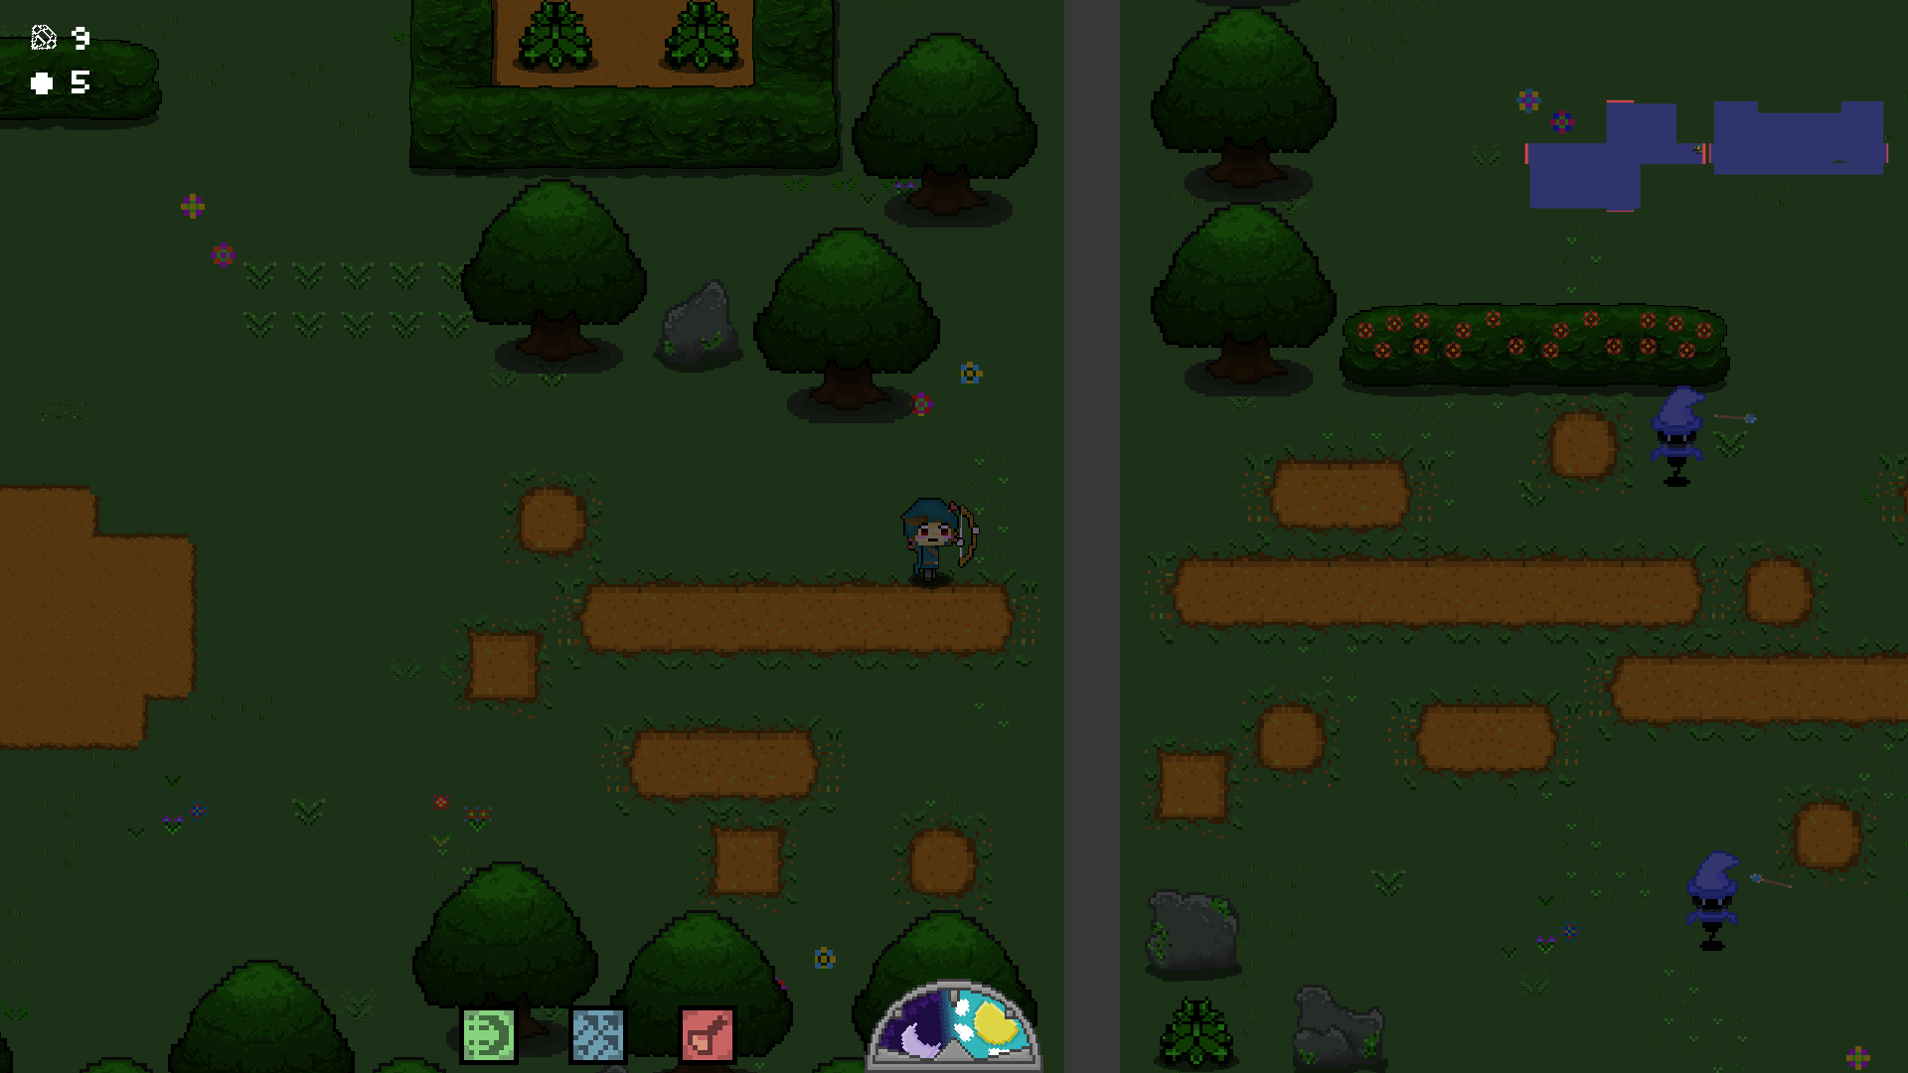

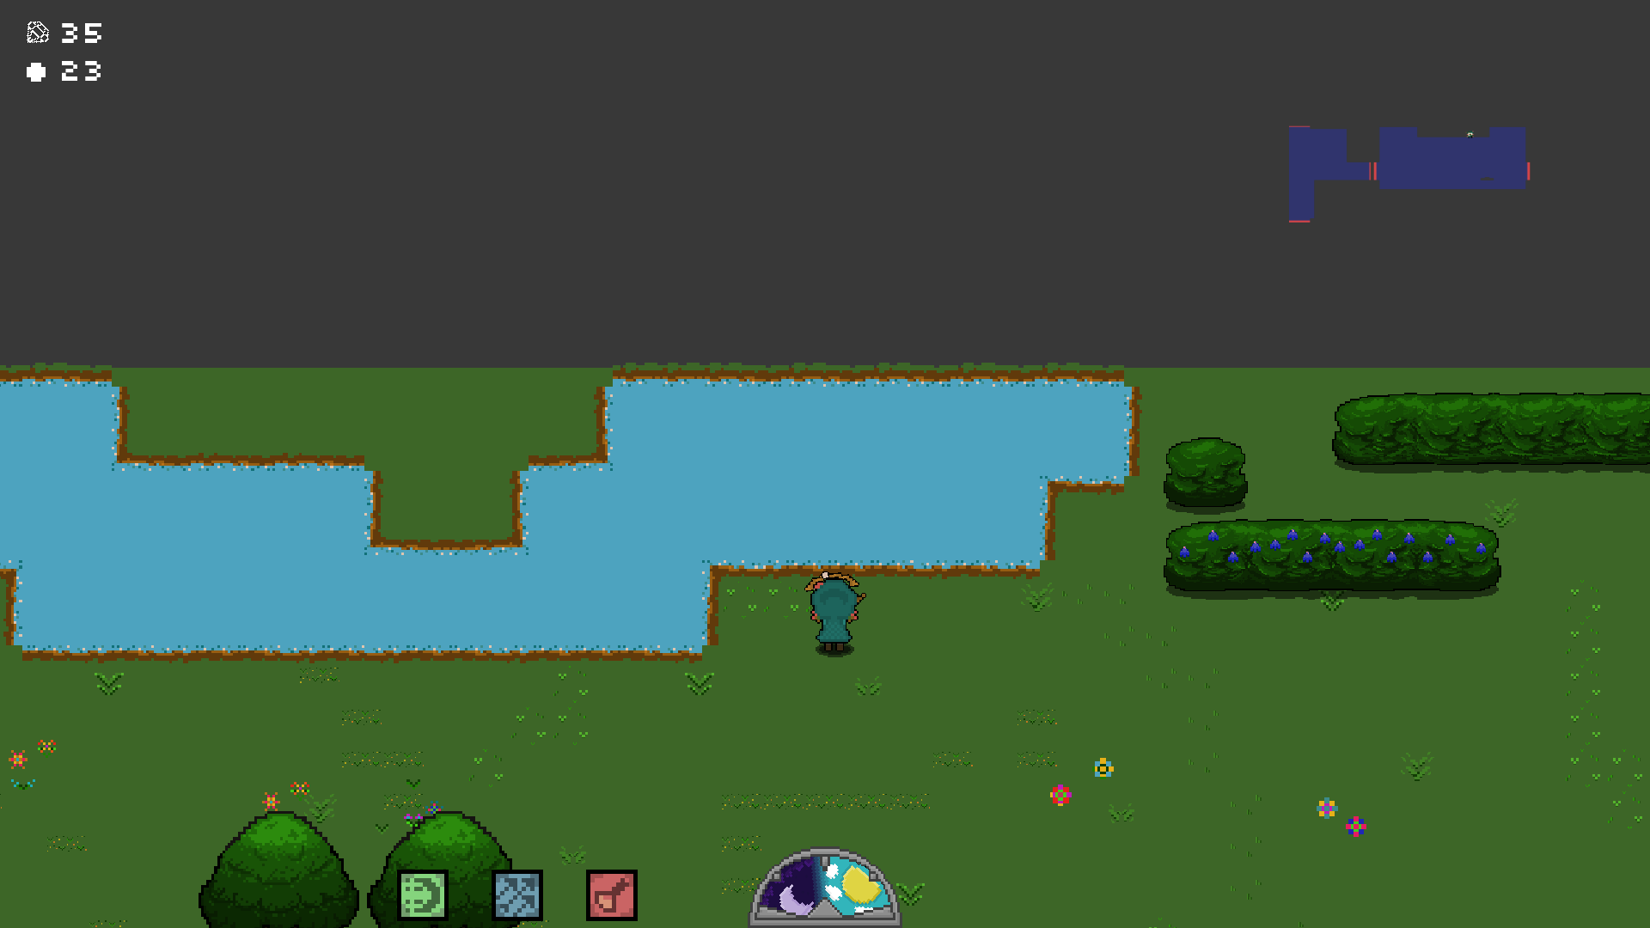Borders between certain tiles are grey.

Greater immersion would be achived by filling this in with trees, something to cover up gaps. Would help a lot.

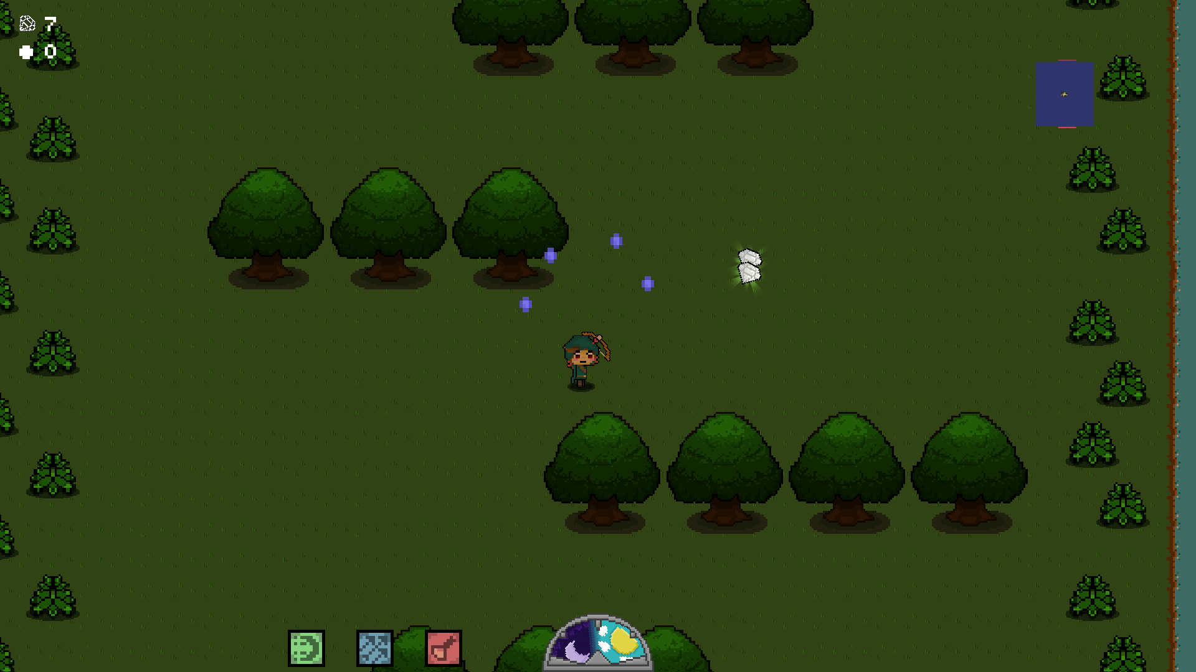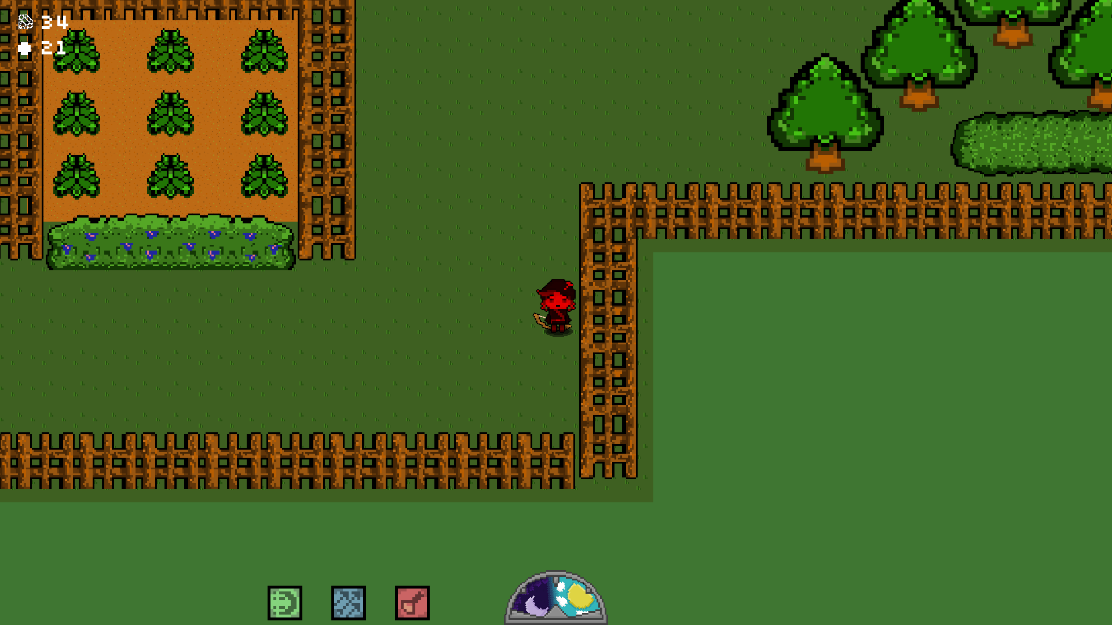again, fill in for tutorial level.

Projectiles from Rock elementals persist after death, still do damage. Also, they do no damage as yet. As in, Health bar telegraphs for damage, but 0 points of damage taken.

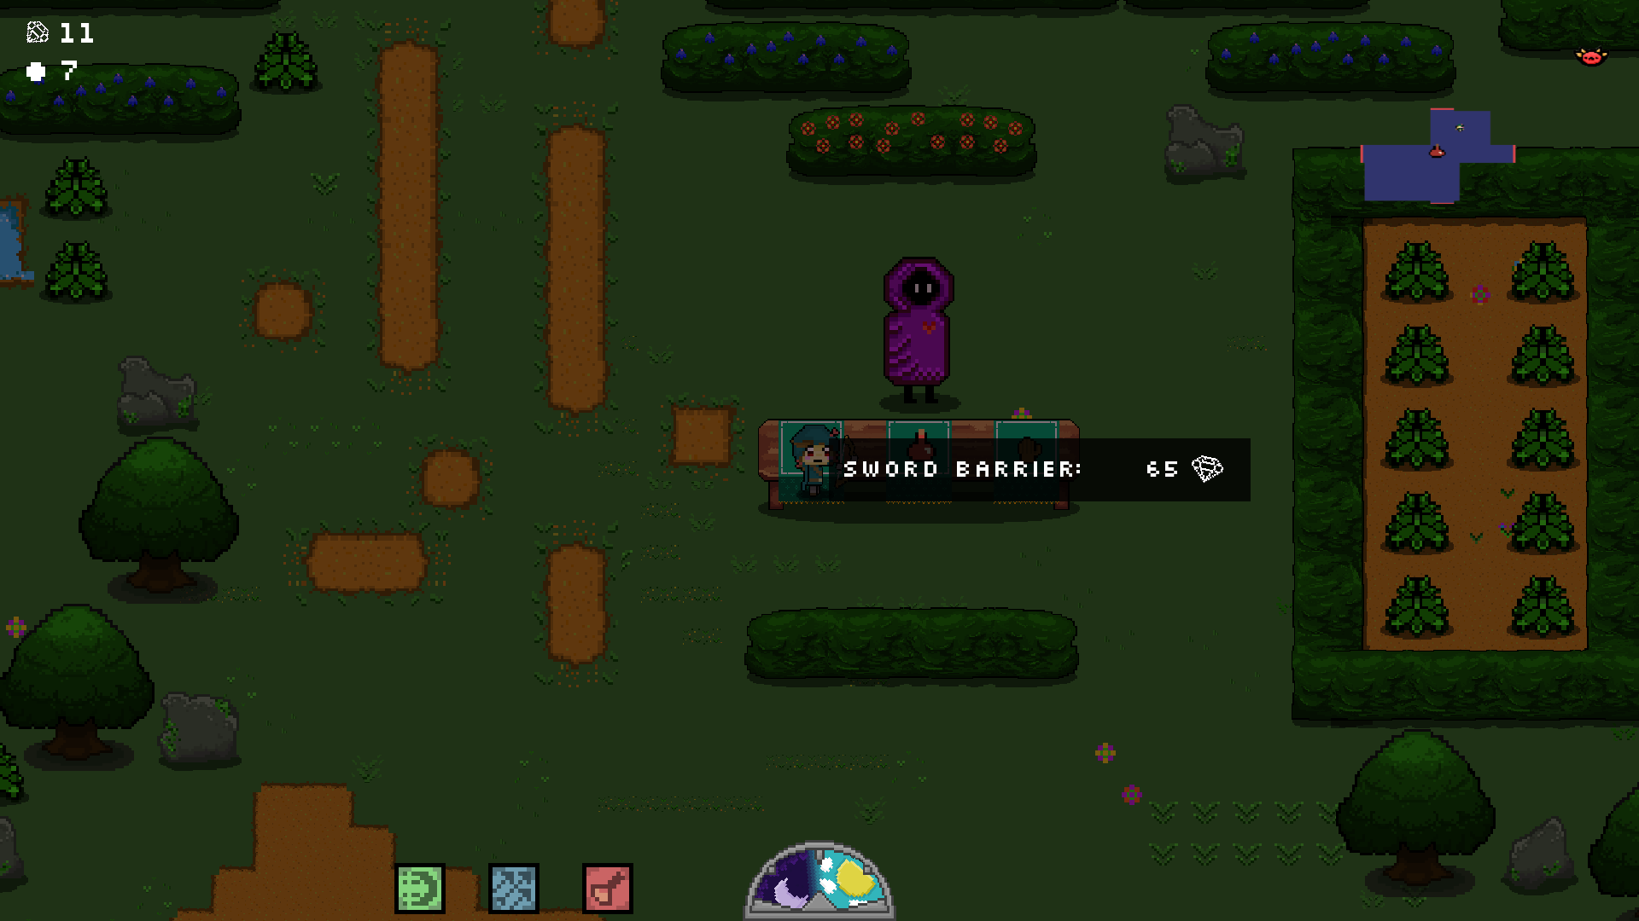

This was called Energy ball the first time I highlighted over it. Maybe a name cross-over? Also, a brief description of what it does would be very helpful.

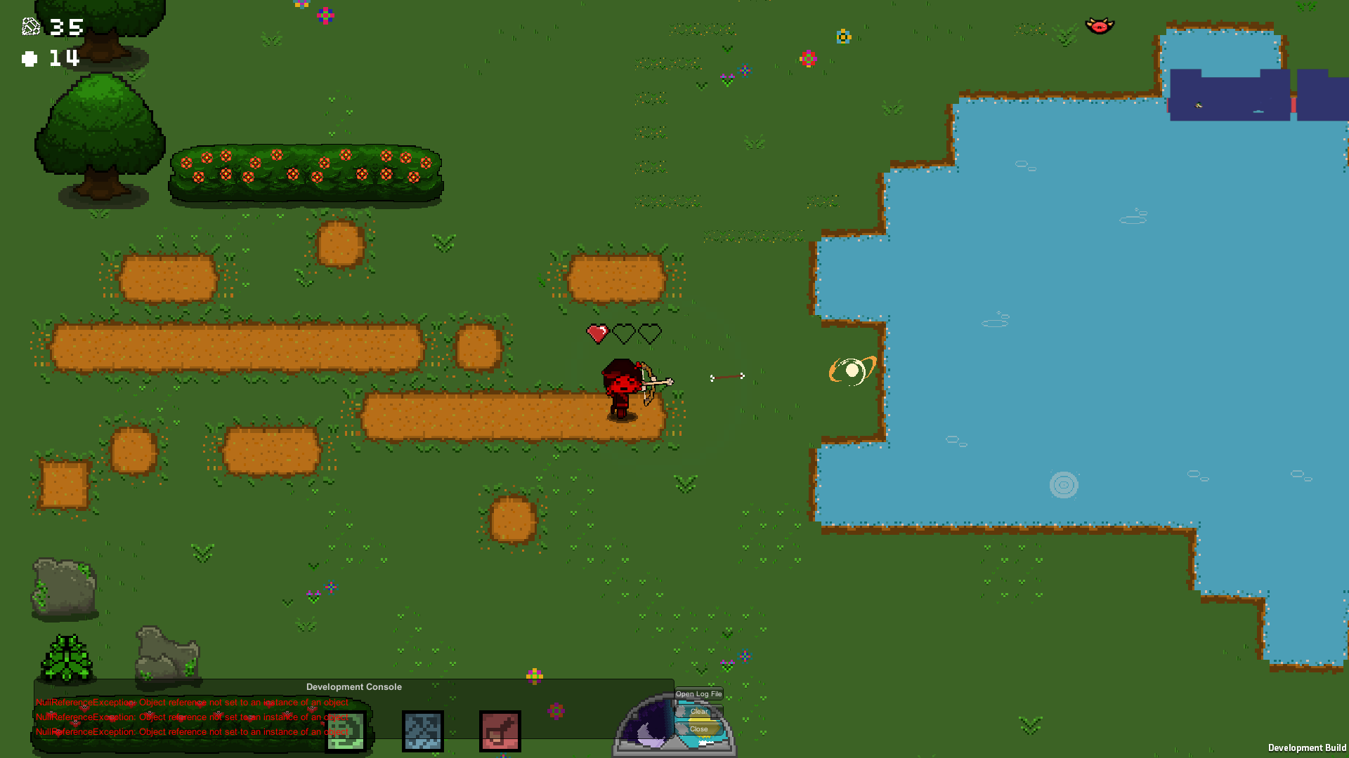

Your projectiles or the enemy projectiles wont travel over the brown water edging. Only projectiles spawned over the brown edge travel over the water.

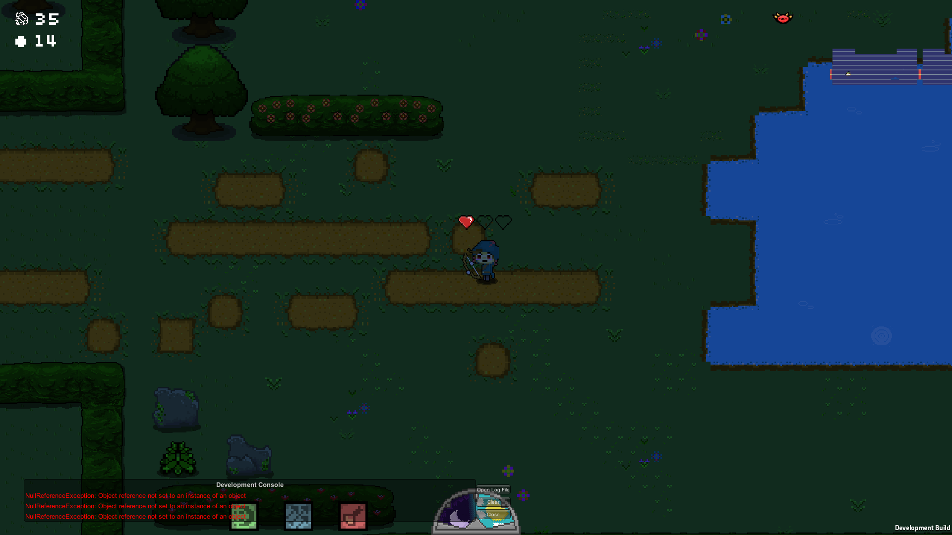

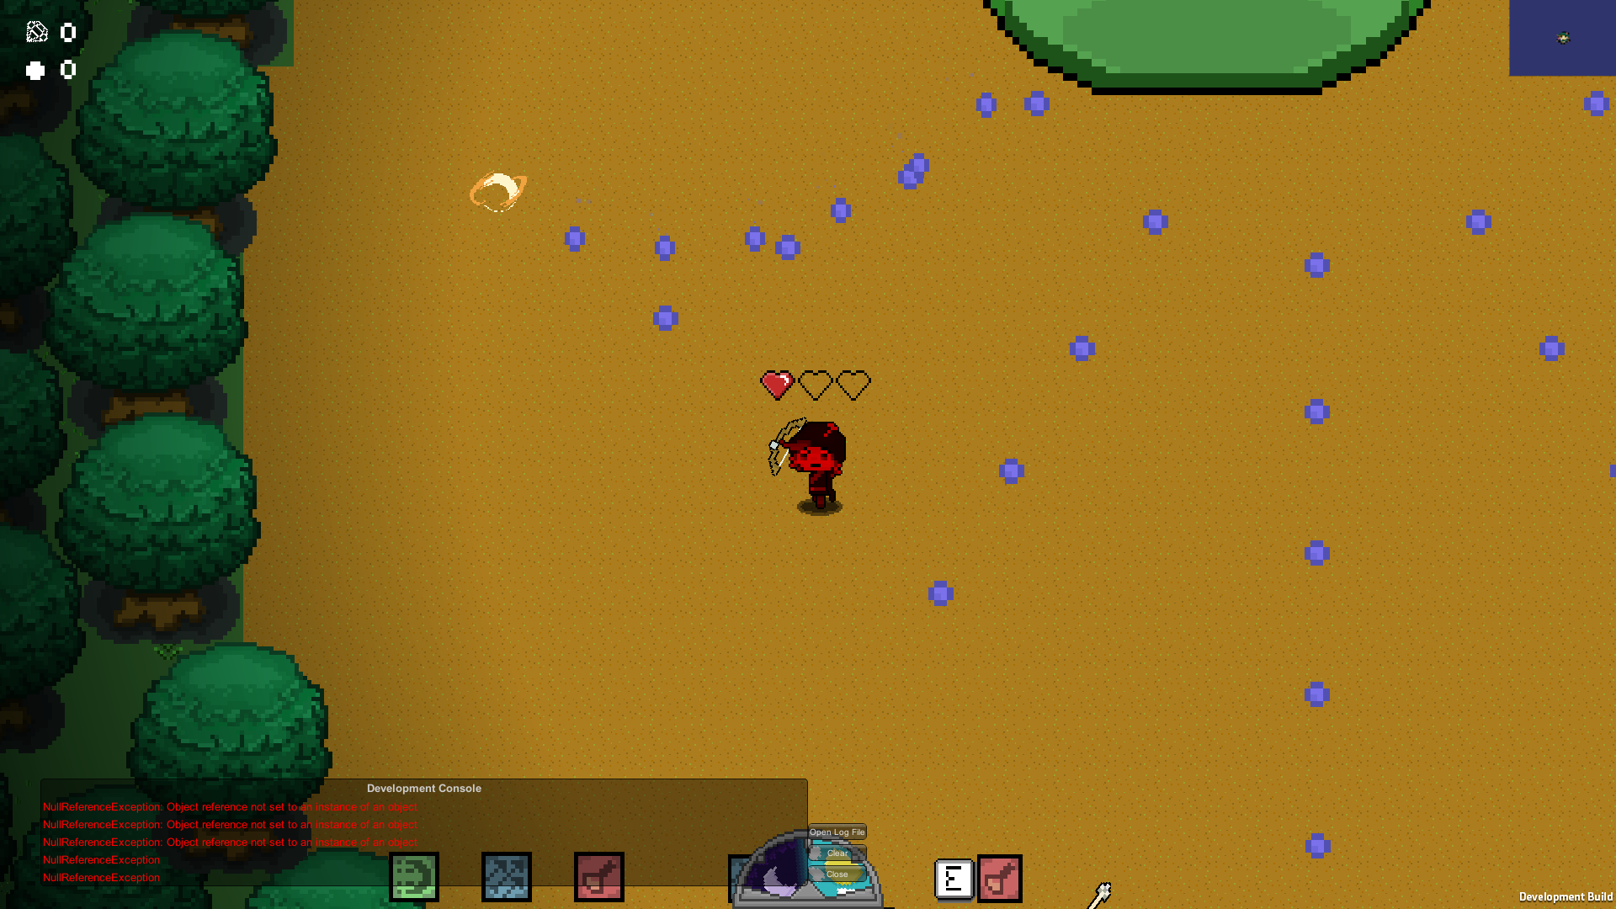Map has a visual artefact when moving, lines appear horizontal and vertical. White and Brown

This is the furthest extent I can travel on the boss map. There is a invisible barrier along the entire left side.